

Tribhuvan University
Faculty of Humanities and Social Sciences

Internship Report

Submitted To

Department of Computer Application Itahari Namuna College
In partial fulfilment of the requirements for the degree of Bachelor’s in Computer Application.

Submitted By
Name: Homanath Adhikari Khatri
Regd. No: 6-2-1152-28-2022

Under the Supervision of
Nabin Shrestha

Lecturer

MENTORS' RECOMMENDATION FROM COMPANY

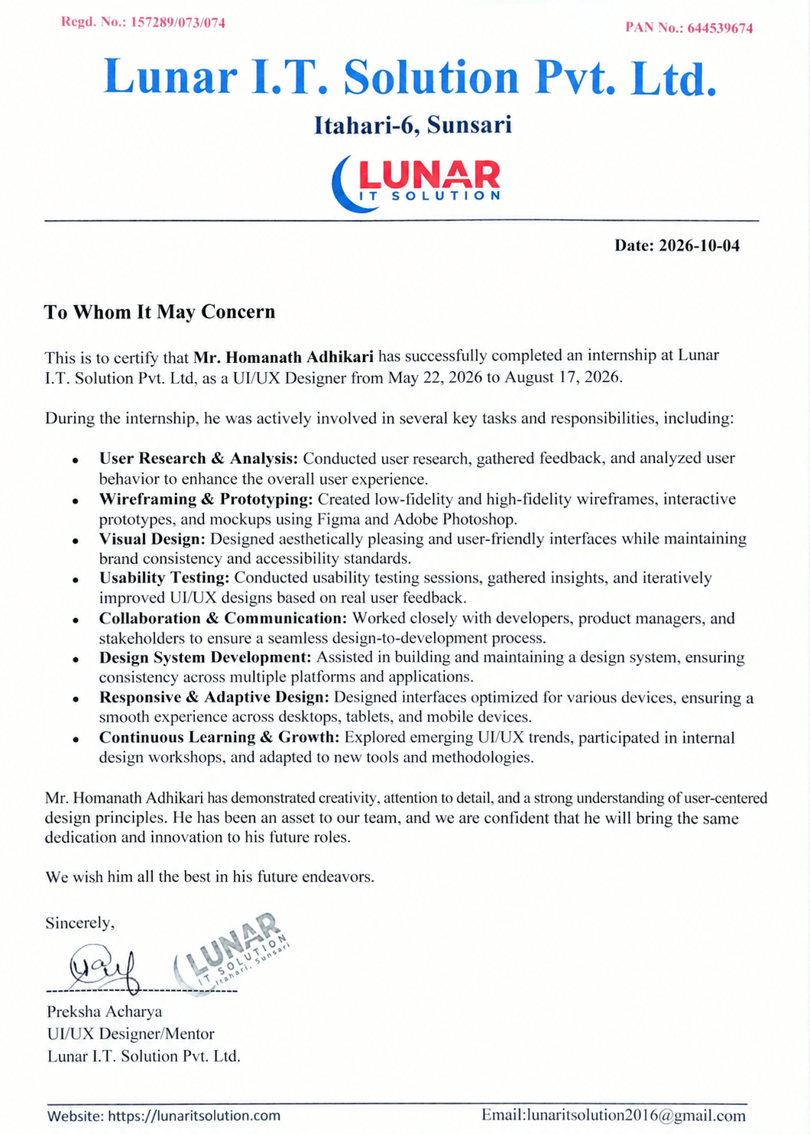


Tribhuvan University
Faculty of Humanities and Social Science ITAHARI NAMUNA COLLEGE

SUPERVISOR’S RECOMMENDATION

I hereby recommend that this internship report prepared under my supervision by Homanath Adhikari Khatri on UI/UX in partial fulfillment of the requirement for the degree of Bachelor of Computer Application is recommended for the final evaluation.

……………….
Nabin Shrestha Project Supervisor
Itahari Namuna College
Itahari-8, Sunsari


Tribhuvan University
Faculty of Humanities and Social Science Itahari Namuna College

LETTER OF APPROVAL

This is to certify that this internship report prepared Homanath Adhikari Khatriin partial fulfilment of the requirements for the degree of Bachelor in Computer Application has been evaluated. In our opinion, it is excellent, and is satisfactory in the scope and quality as an internship report for the required degree.

Nabin Shrestha Supervisor  Itahari Namuna College |  | Er. Chandra Prashad Acharya  CEO  Lunar IT Solution PVT.LTD
Nabin Shrestha HOD  Itahari Namuna College |  | External Examiner Tribhuvan University

ACKNOWLEDGEMENT
I would like to express my heartfelt appreciation to everyone who have contributed to the success of UI/UX internship at Lunar IT Solution Pvt. Ltd.
First and foremost, I express my sincere gratitude to my esteemed mentor
Preksha Acharya, for his invaluable guidance, continuous support, and encouragement throughout the internship. His expertise in UI/UX design and patient teaching approach played a significant role in our professional growth and learning.
I would also like to extend my sincere thanks to my internship supervisor, Nabin Shrestha, for his valuable guidance, support and constructive feedback throughout the internship. His mentorship greatly enhanced my learning experience and professional development.
I am grateful to my colleagues at Lunar IT Solution Pvt. Ltd for their support, collaboration, and willingness to share their knowledge and experiences. Their insights and teamwork provided me with valuable exposure to real-world UI/UX design practices.
Finally, I would like to express my deepest gratitude to my family and friends for their constant encouragement, understanding, and unwavering support throughout this journey. Their motivation gave me the confidence to learn, grow, and successfully complete this internship.
Thank you to everyone who contributed to making my UI/UX internship at Lunar IT Solution Pvt. Ltd. a meaningful and rewarding experience. I truly appreciate your support and look forward to applying the knowledge and skills I have gained in my future career.

Thank You

ABSTRACT

The UI/UX Design internship at Lunar IT Solution Pvt. Ltd. provided an enriching opportunity to explore the principles and practices of modern user interface and user experience design. During the internship, the intern worked on the Lunar IT Solution Website, focusing primarily on designing the mobile application interface for teachers. The project aimed to provide teachers with an intuitive and efficient platform for managing their academic activities, including viewing assigned classes, checking student information, managing attendance, accessing notifications, and managing profile and availability.

The internship involved understanding user requirements, analyzing teacher workflows, creating wireframes, designing high-fidelity mobile interfaces, and developing interactive prototypes using Figma. Particular attention was given to consistent visual hierarchy, typography, spacing, navigation, reusable UI components, and user-friendly interactions. The design process followed a user-centered approach to ensure that the interface was simple, clear, and suitable for teachers' daily tasks. The project also helped the intern understand the differences between teacher and student user roles within a Lunar IT Solution Website.

Overall, the internship at Lunar IT Solution Pvt. Ltd. strengthened the intern's practical knowledge of UI/UX design, Figma, prototyping, user-flow development, and mobile application design. It provided valuable exposure to real-world design practices and contributed significantly to the intern's professional growth in the field of UI/UX design.

Keywords: Figma, Lunar IT Solution Website, Mobile Application Design, Prototyping, UI/UX Design, User-Centered Design, Wireframing

TABLE OF CONTENTS
MENTORS' RECOMMENDATION FROM COMPANY ii
SUPERVISOR’S RECOMMENDATION iii
LETTER OF APPROVAL iv
ACKNOWLEDGEMENT v
ABSTRACT vi
LIST OF FIGURES viii
LIST OF ABBREVIATIONS ix
CHAPTER 1: INTRODUCTION 1
  - Project Introduction 1
  - Problem statement 2
  - Objectives… 2
  - Scope and Limitations 3
  - Report Organization 4
CHAPTER 2: INTRODUCTION TO ORGANIZATION 5
  - Organization Details 5
  - Organizational Hierarchy 6
  - Working Domains of Organization 6
  - Description of the Intern Department 7
CHAPTER 3: BACKGROUND STUDY AND LITERATURE REVIEW 9
  - Background Study 9
  - Literature Review………………... 9
CHAPTER 4: INTERNSHIP ACTIVITIES 11
  - Roles and Responsibilities 11
  - Weekly log of Internship Activities 12
  - Project Description: Lunar IT Solution Website 20
  - Activities Performed 20
CHAPTER 5: CONCLUSION AND LEARNING OUTCOMES 23
  - Conclusion 23
  - Learning Outcome 23
REFERENCES 25
APPENDICES 26
Appendix 1: Screenshots 26
Appendix 2: Internship Certificate 28

LIST OF FIGURES
Figure 1: Organizational Hierarchy of Lunar IT Solution Pvt. Ltd 6

LIST OF ABBREVIATIONS

UI | User Interface
UX | User Experience

CHAPTER 1: INTRODUCTION

Introduction
During my internship at Lunar IT Solution Pvt. Ltd., I immersed myself in the field of UI/UX design. This experience allowed me to explore various design concepts, tools, and techniques while developing user-friendly and visually appealing interfaces. The internship provided me with an opportunity to apply my academic knowledge in a professional environment, improve my creative and problem-solving abilities, and gain practical experience in the UI/UX design process.
During the internship, I learned and practiced Figma and various UI/UX concepts such as grids, color theory, spacing, alignment, grouping, Auto Layout, wireframing, and prototyping. I worked on different desktop and mobile UI design tasks and gradually improved my understanding of the UI/UX design process.
As part of the internship, I contributed to the UI/UX design of a Lunar IT Solution Website. My primary responsibility in this project was designing the. I worked on planning and designing different screens for the teacher-side application according to the project requirements. I applied concepts such as Auto Layout, grouping, color selection, typography, spacing, and prototyping to create a consistent and user-friendly mobile interface.
The internship also provided opportunities to communicate and collaborate with mentors and team members, receive constructive feedback, and improve my designs accordingly. These interactions helped me develop not only my technical and design skills but also my communication, teamwork, time management, and ability to work according to project requirements.
Overall, the internship at Lunar IT Solution Pvt. Ltd. was a valuable learning experience that helped bridge the gap between academic knowledge and practical application. The combination of hands-on design tasks, real-world project experience, mentorship, and continuous practice strengthened my knowledge of UI/UX design and prepared me for future opportunities in the field of design and technology.

1.2 Problem Statement
During my internship at Lunar IT Solution Pvt. Ltd., while working with UI/UX design tools, particularly Figma, several challenges and issues were encountered regarding the corporate website's structure and user experience. These challenges affected the design process and required continuous practice and iteration. The following are key challenges addressed during the project:
- Inadequate Digital Presence and Page Layouts: The existing layout lacked an engaging structure for prospective clients, students, and applicants seeking information about company services, portfolio, and internship programs.
- Complex Navigation and User Flows: Users faced difficulties seamlessly navigating between information hubs—such as exploring completed projects in the gallery, viewing internship opportunities, or accessing login and enrollment portals.
- Need for an Intuitive and Unified Web Interface: The Lunar IT Solution Website required an aesthetically pleasing, consistent, and user-friendly interface that clearly showcases company offerings while offering friction-free user flows for logins, enrollments, and inquiries.

1.3 Objective
To design a modern, responsive, visually consistent, and user-friendly web application interface for the Lunar IT Solution Website using Figma—focusing specifically on the Landing Page, Gallery Page, Internship Page, Enrolled Page, Login/Authentication Page, and streamlined user navigation flows.

Scope and Limitations
During my internship at Lunar IT Solution Pvt. Ltd, the scope and limitations of the UI/UX design activities were as follows:
Scope:

    - Designing user-friendly and visually appealing interfaces using Figma.
    - Creating structural wireframes, visual layouts, and interactive web prototypes based on company requirements.
    - Applying UI/UX principles such as grids systems, typography, color hierarchy, Auto Layout, and design system components
    - Collaborating closely with a peer designer to brainstorm design systems, divide web page modules, and align on cohesive UI decisions.
    - Refining interface layouts based on mentor evaluations, design reviews, and continuous feedback loops.
Limitations:

    - The internship mainly focused on UI/UX design, with limited involvement in the actual development and implementation of the application.
    - Time constraints restricted extensive user testing with external end-users.
    - Primary design efforts were centered on specific public-facing and onboarding user flows of the website rather than backend administrative management portals.
    - Design decisions relied primarily on provided corporate specifications, peer collaboration, and mentor guidance rather than large-scale market research.

1.4 Report Organization

This internship report is organized into the following sections:

Chapter 1: Introduction

Provides an overview of the internship, including the problem statement, objectives scope and limitations, and organization of the report.
Chapter 2: Introduction to Organization

Introduces Lunar IT Solution Pvt. Ltd, the organization where the internship took place. This section includes details about the company, its organizational structure, working areas, and an overview of the intern department/unit.
Chapter 3: Background Study and Literature Review

Discusses fundamental concepts, principles, tools, and terminologies related to UI/UX design, including Figma, wireframing, prototyping, color theory, grids, Auto Layout, and mobile application design. It also reviews related concepts and existing systems.
Chapter 4: Internship Activities

Describes the roles, responsibilities, and weekly activities undertaken during the internship. It presents the practical tasks completed using Figma and explains the design process of the Teacher Mobile Application developed as part of the Lunar IT Solution Website.
Chapter 5: Conclusion and Learning Outcomes

Summarizes the overall internship experience, major achievements, and skills gained during the internship. It also discusses the knowledge and practical experience gained in UI/UX design, Figma, mobile application design, wireframing, and prototyping, along with their relevance to future career development.

CHAPTER 2: INTRODUCTION TO ORGANIZATION

2.1 Organization Details

Lunar IT Solution Pvt. Ltd, headquartered in Itahari, Sunsari, Nepal, is a prominent IT company founded by Er. Chandra Prasad Acharya. Since its establishment, the company has been providing a wide range of technology-based services to individuals, businesses, and organizations. Lunar IT Solution focuses on delivering practical, reliable, and innovative solutions according to the specific requirements of its clients.
Key Details:

Founder: Er. Chandra Prasad Acharya

Location: Itahari Sunsari, Nepal

Services: Lunar IT Solution specializes in Software Development, Mobile Application Development, Web Design, Graphic Design, UX/UI Design, Social Media Management, Networking, and other IT-related services.
Mission: Lunar IT Solution Pvt. Ltd. is committed to providing high-quality and innovative IT solutions that exceed client expectations and contribute to their success in the digital environment.
Vision: The company aims to become a leading provider of cutting-edge technology solutions, recognized for its excellence, integrity, innovation, and customer satisfaction.
The company works with modern technologies and development practices to create efficient and user-friendly digital solutions. Its services are designed to help clients improve their digital presence, automate business activities, and effectively utilize modern technology. Lunar IT Solution also emphasizes creativity and continuous learning to keep up with the rapidly changing IT industry.
At Lunar IT Solution Pvt. Ltd., the team is dedicated to leveraging the latest technologies and expertise to deliver effective results for clients. With a strong focus on quality, innovation, professionalism, and customer satisfaction, the company strives to remain a reliable technology partner for businesses and organizations seeking efficient and modern IT solutions.

2.2 Organizational Hierarchy

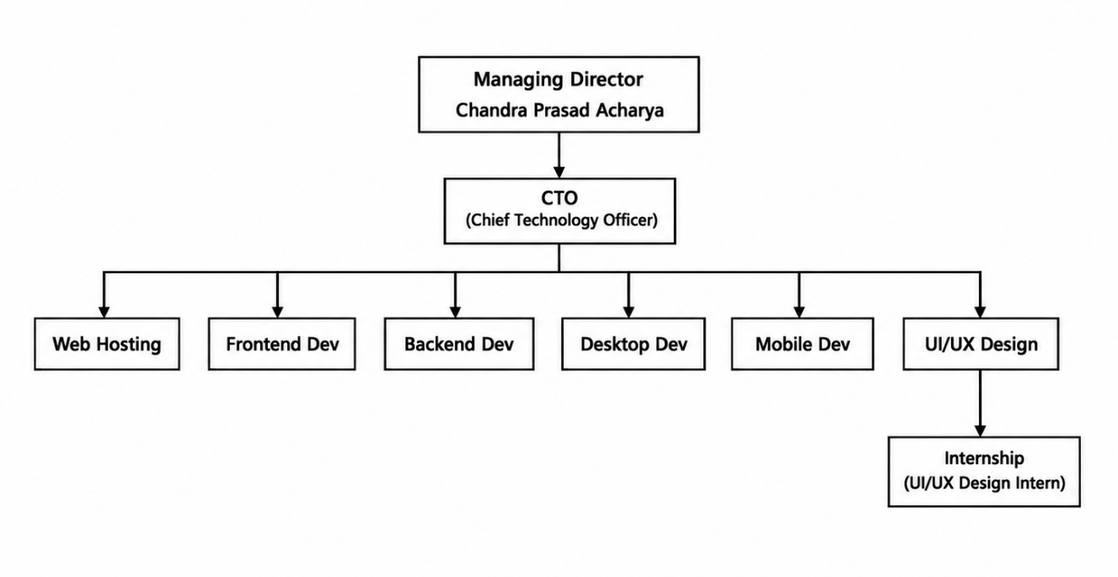

Figure 1: Organizational Hierarchy of Lunar IT Solution

In our organization, the CEO holds the highest leadership position and bears ultimate responsibility for the company's direction and achievements. Directly beneath the CEO is the CTO, tasked with overseeing the development and maintenance of the company's entire web application, front-end and back-end systems along with the database. The front-end developer concentrates on crafting the design and functionality of the user interface, while the UI/UX developer works towards enhancing the user experience and usability of the application. Lastly, the intern serves as a junior member of the team, gaining practical experience and learning from senior developers. This hierarchical structure ensures a clear chain of command and delineation of responsibilities.

2.3 Working Domains of Organization
Lunar IT Solution Pvt. Ltd is a technology company, comprising skilled professionals in the fields of Computer Science and Information Technology. Our focus is on research and development to enhance the lives of individuals and businesses. Some common working domains of Lunar IT Solution Pvt. Ltd include:
Website Development: Lunar IT Solution Pvt. Ltd specialize in designing and developing stunning websites for businesses, facilitating their growth in the digital realm.
Mobile App Development: Lunar IT Solution Pvt. Ltd is engaged in cross-platform mobile app development for both Android and iOS platforms, empowering businesses to thrive in the digital space.
Cloud Solutions: Lunar IT Solution Pvt. Ltd provide cloud-based solutions tailored to the needs of individuals and businesses, offering custom plans to suit their requirements.
Digital Marketing: Lunar IT Solution Pvt. Ltd offers digital marketing services for products, services, and businesses of all sizes, ensuring effective online promotion and visibility.
UI/UX Designing: Lunar IT Solution Pvt. Ltd assists in enhancing the user experience and interface design of applications, software, and websites for individuals and businesses.
Social Media Boosting: Lunar IT Solution Pvt. Ltd provide social media boosting services on popular platforms such as Facebook, Messenger, and Instagram, helping clients reach their targeted audience effectively.
Web App Development: Lunar IT Solution Pvt. Ltd offers custom web application development services, covering UI/UX design, front-end and back-end development, QA testing, and maintenance.
Software Development: From smart customization to full-cycle software development, we specialize in delivering reliable and cost-effective software solutions tailored to clients' needs.

2.4 Description of the Intern Department
The intern department at Lunar IT Solution Pvt. Ltd is a dynamic and integral part of our organization, contributing to our operations and goals. It serves as a platform for students and recent graduates interested in pursuing careers in the technology industry, providing them with valuable learning opportunities and hands-on experience.
Key functions of the intern department include:

    - Offering tailored learning and development opportunities to interns.
    - Assisting other teams and departments within Lunar IT Solution Pvt. Ltd in various projects and tasks.
    - Identifying and nurturing talented individuals who have the potential to join Lunar IT Solution Pvt. Ltd as full-time employees.
    - Participating in training and development programs to enhance skills and knowledge in relevant areas.
    - Undertaking assignments and tasks aligned with interns' field of study or career aspirations.
The intern department fosters a supportive and inclusive culture, emphasizing professional growth and personal development. Interns have the chance to collaborate with experienced professionals, learning from their expertise and tackling challenges that contribute to their skill enhancement.

CHAPTER 3: LITERATURE REVIEW

3.1 Background Study

During my internship at Lunar IT Solution Pvt. Ltd., I focused on UI/UX design using Figma as the primary design and prototyping tool. User Interface (UI) focuses on the visual presentation, typography, grid structure, and interactive components, while User Experience (UX) emphasizes usability, intuitive information architecture, and efficient user flows (Garrett, 2010). Human-centered design principles guided our work to keep user goals at the heart of design iterations.
I studied and implemented fundamental UI/UX concepts including grid systems, color theory, typography scale, spacing rules, alignment, component grouping, and Auto Layout. These concepts enabled the creation of clean, visually balanced web layouts. Figma's collaborative capabilities, design systems, and reusable components were essential when co-designing pages alongside my project partner to maintain unified style standards across the site (Tidwell et al., 2020).
I also gained practical knowledge of wireframing and prototyping. Wireframes helped me plan the structure and layout of application screens before developing the final interface, while prototypes helped me represent screen navigation and user interactions. Figma provides tools for creating both wireframes and interactive prototypes within the design workflow (Figma Inc., 2030; Norman, 2002).
The knowledge gained during the internship was applied to the Lunar IT Solution Website, where I was primarily responsible for designing key web pages and user flows, including the Landing Page, Gallery Page, Internship Page, Enrolled Page, and Login Page. Working in close collaboration with my project partner, this background study provided me with the necessary theoretical and practical foundation to create user-friendly, responsive, and visually consistent web application interfaces.

3.2 Literature Review
Norman (2002) stresses the importance of human-centered design in making digital tools intuitive. Interfaces must clearly convey affordances, provide immediate feedback, and lower cognitive load. These principles directly informed the visual architecture of the website’s main navigation, landing call-to-action buttons, and user login forms.
Nielsen (1994) introduced ten usability heuristics, including consistency, visibility of system status, error prevention, and recognition over recall. Applying these heuristics ensured consistent layout structures, uniform color coding, and predictable user flows across all website pages.
Krug (2014) advocates for effortless web navigation, arguing that users should navigate pages without confusion ("Don't Make Me Think"). This principle guided the structural design of the Landing Page, Gallery, and Enrollment sections, ensuring clear typographic hierarchy and intuitive visual flow.
Figma provides an integrated web platform for wireframing, design systems, real-time co-design, and interactive prototyping (Figma Inc., 2030; Norman, 2002). Using Figma enabled seamless peer collaboration, swift design revisions based on feedback, and accurate prototype creation for the complete web project.
Overall, the reviewed concepts and design principles provided a theoretical foundation for designing the Teacher Mobile Application. The literature helped guide decisions related to usability, navigation, consistency, visual organization, wireframing, and prototyping throughout the project.

CHAPTER 4: INTERNSHIP ACTIVITIES

Roles and Responsibilities
During my internship at Lunar IT Solution Pvt. Ltd, I was involved in various UI/UX design activities and contributed to the design process of a Lunar IT Solution Website. As a UI/UX Design Intern, my primary roles and responsibilities included:
Web UI/UX Design: I participated in designing user interfaces based on user requirements and basic UI/UX principles. I focused on creating simple, attractive, and user-friendly interfaces using Figma.

Peer Co-Designing & Collaboration: Partnering closely with my peer intern to brainstorm site architecture, establish color/typography tokens, and co-design main website pages.

Layout Design for Website Modules: I designed five core web pages: Landing, Gallery, Internship, Enrolled, and Login. Using Figma Auto Layout and responsive grids, I created clean and modern interfaces. I focused on clear navigation, strategic CTAs, and intuitive dashboard elements to improve usability. I collaborated with my project partner to maintain consistent typography, colors, and visual hierarchy. The final design provided a cohesive and user-friendly interface aligned with the brand identity.

Prototyping and Interaction Design: I created interactive prototypes by connecting different screens and adding basic interactions and navigation flows. This helped in visualizing how the mobile application would work.

Learning and Skill Development: Throughout the internship, I continuously developed my skills in UI/UX design, Figma, wireframing, prototyping, mobile application design, and design principles. The internship provided me with practical experience in applying UI/UX concepts to a real-world project.

Iterative Design Refinement: Participating in weekly mentor reviews, incorporating feedback, and refining layout spacing, Auto Layout settings, and visual balance.

Weekly log (Technical Details of Activities)

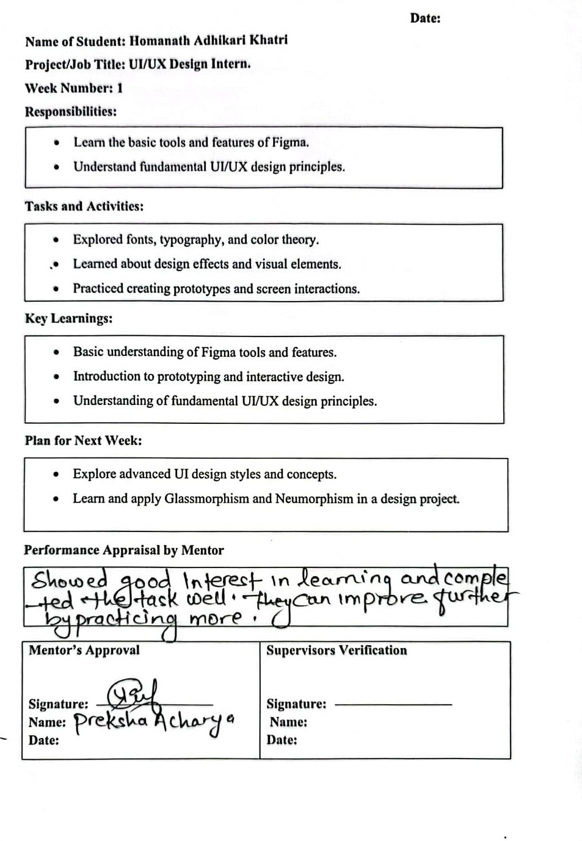

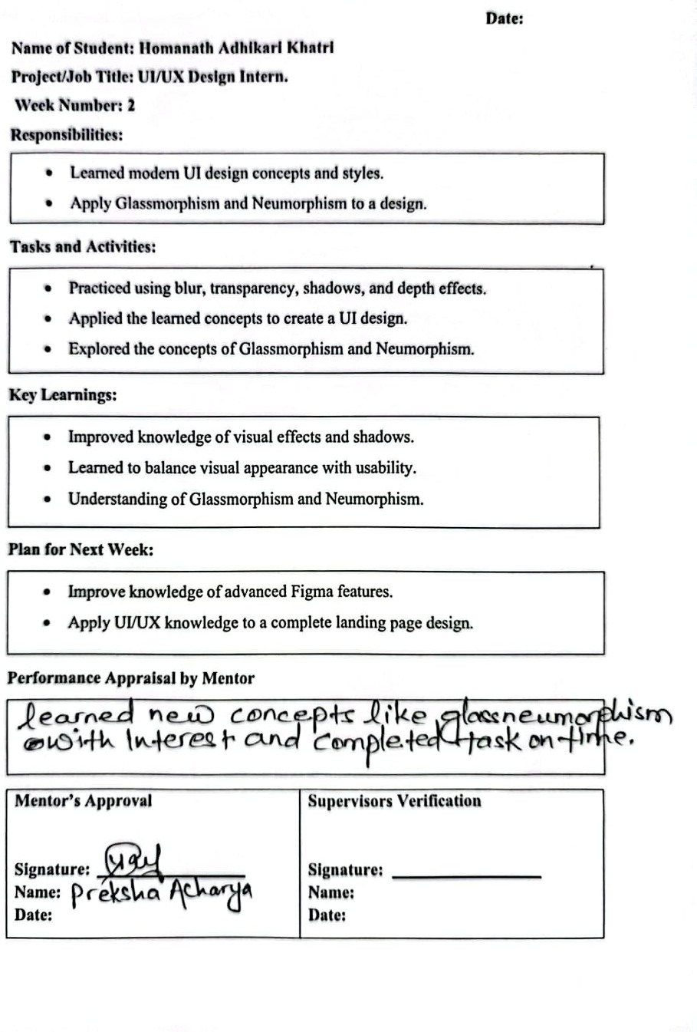

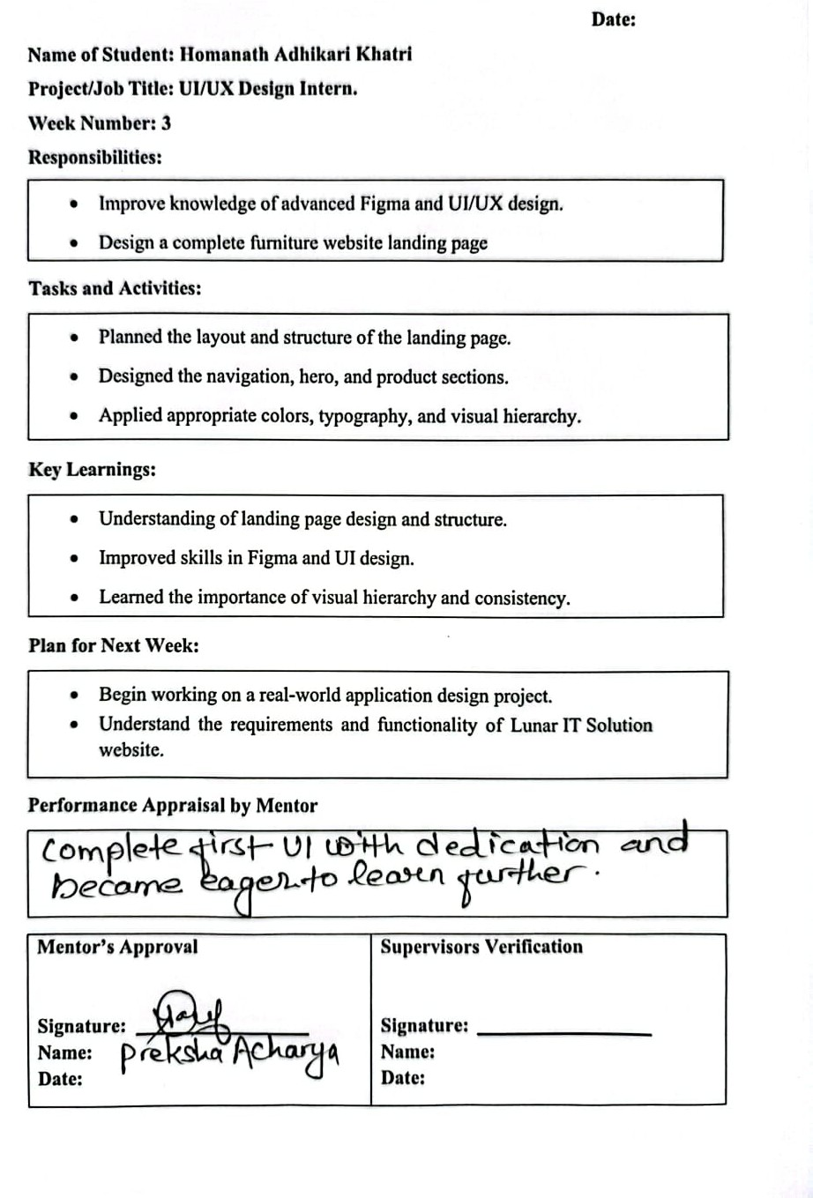

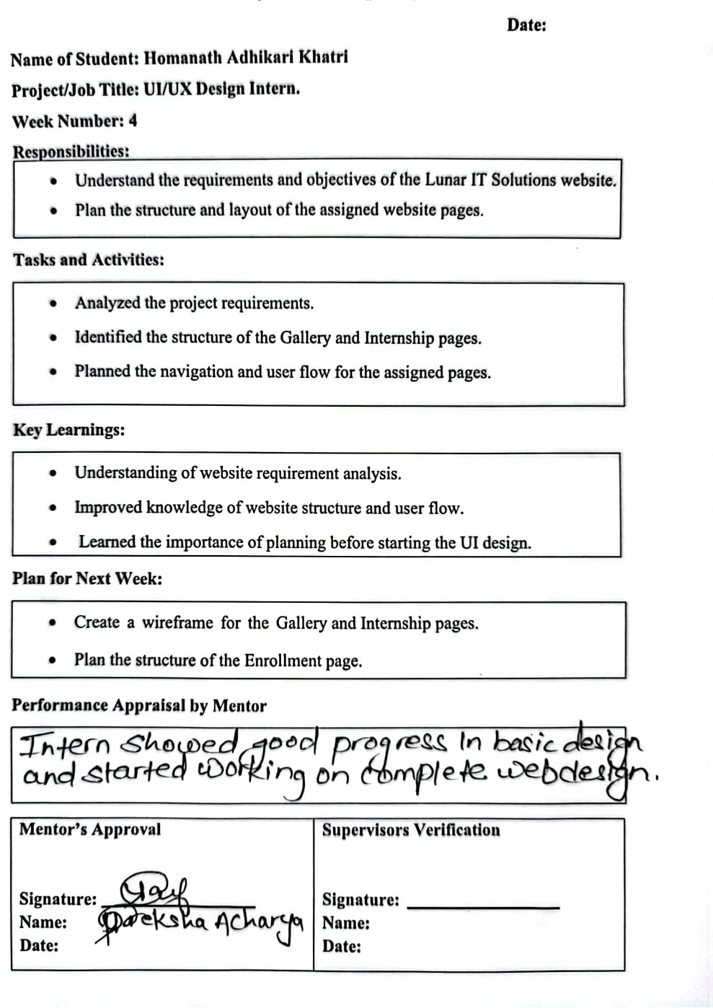

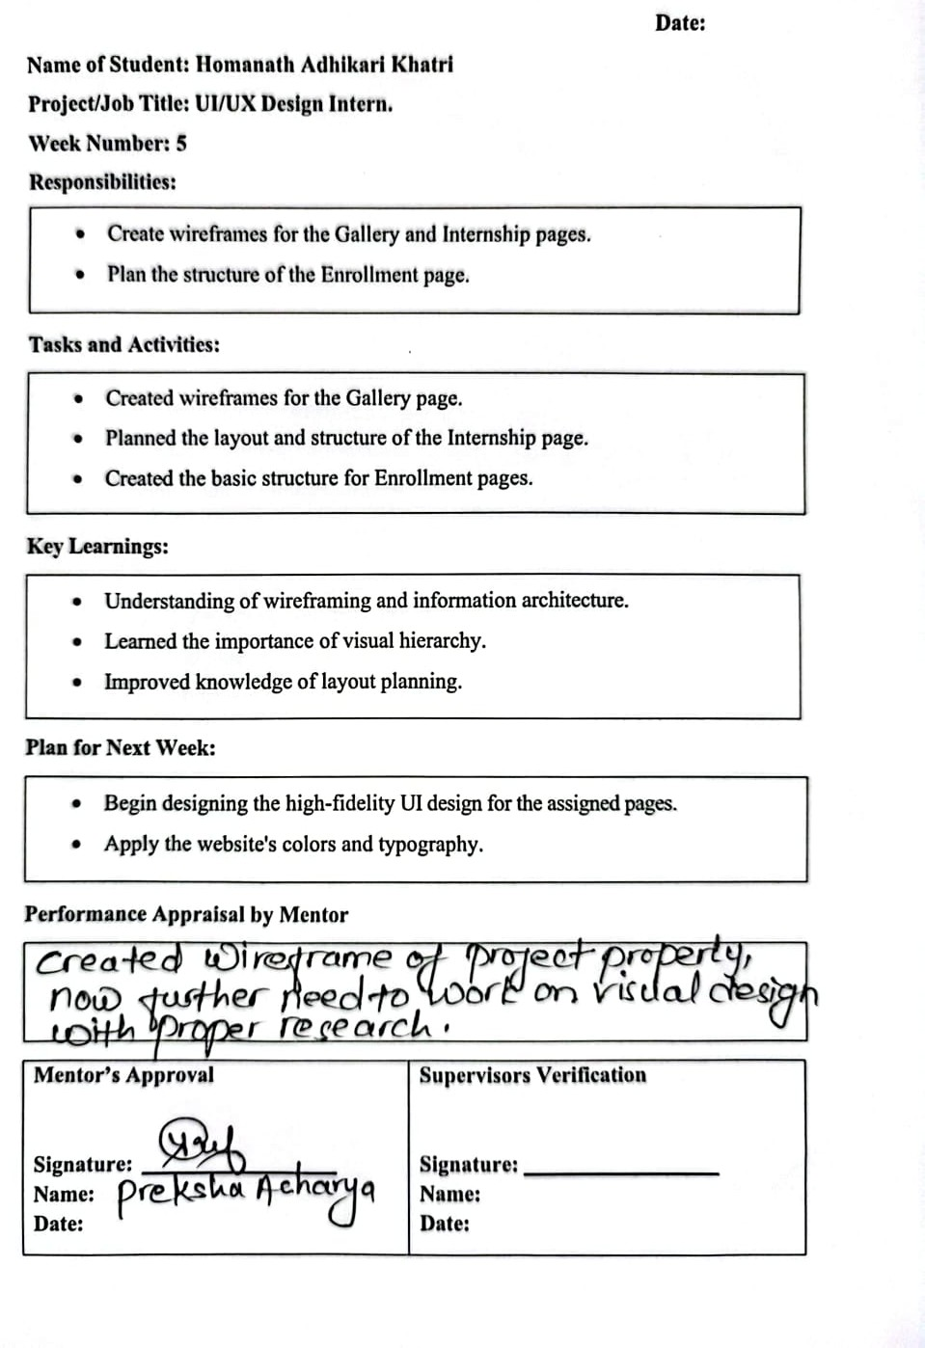

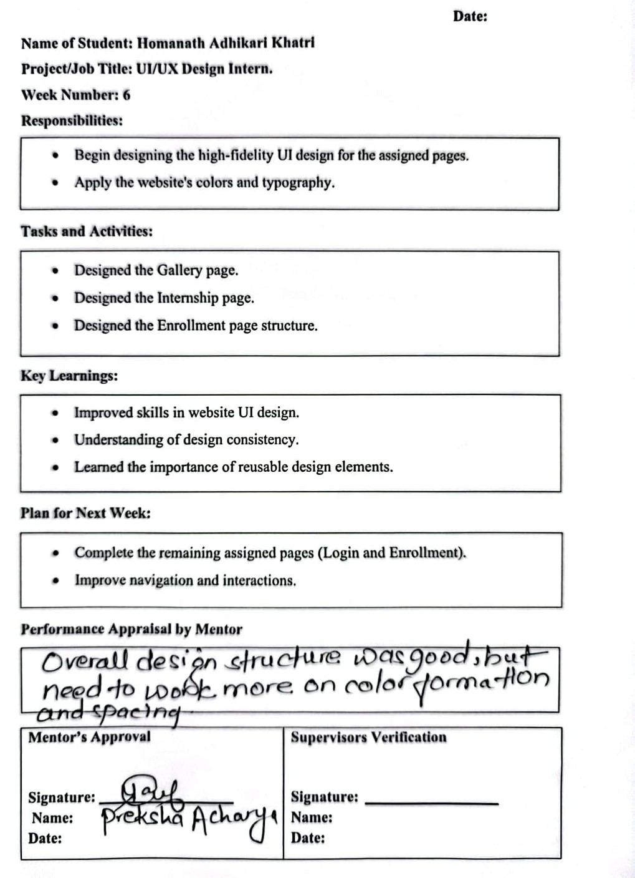

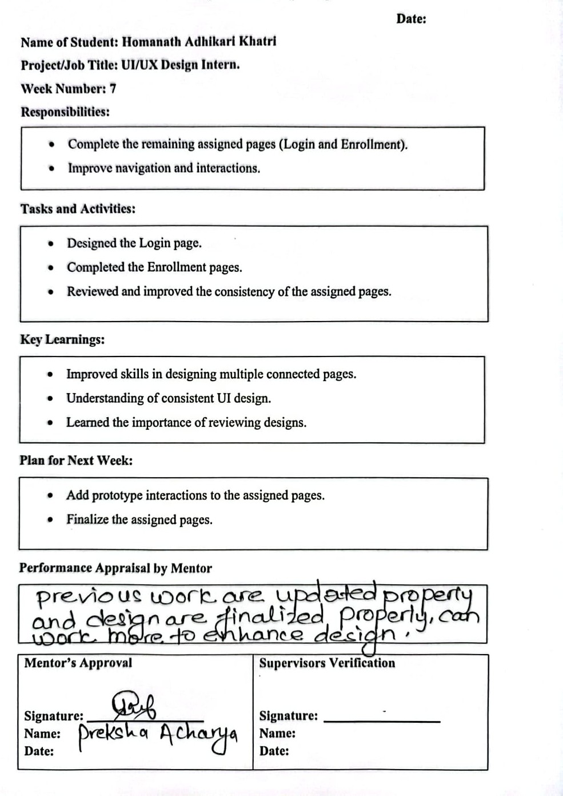

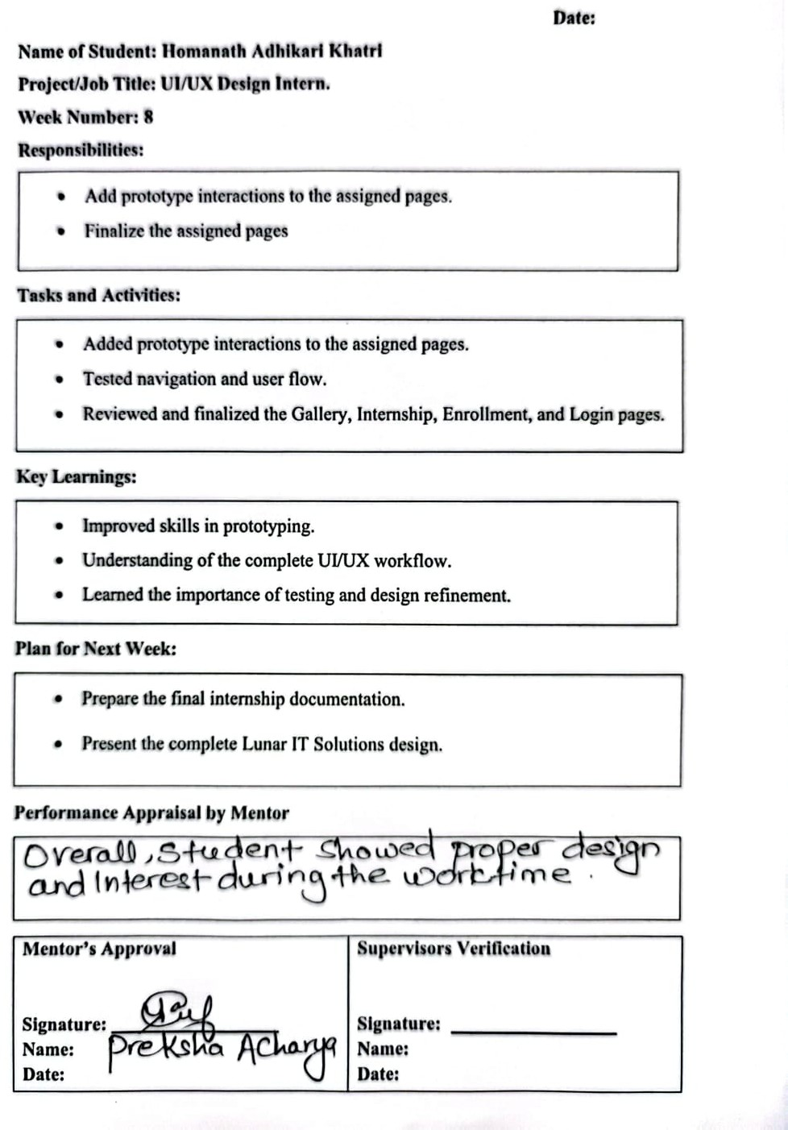

Project Description: Lunar IT Solution Website

The project undertaken during the internship was the Lunar IT Solution Website, a modern web-based platform designed to present the company’s IT services, portfolio, career opportunities, and user-related activities in an organized and accessible manner. The website serves as a digital platform for visitors to explore the company’s services, view its previous works and achievements, learn about internship opportunities, and access registered-user features. The system was designed with a focus on clear information presentation, simple navigation, responsive layouts, and a consistent user experience across different sections of the website.

The project consists of several major sections and user interactions, including the Landing Page, Gallery Page, Internship Page, Enrolled Page, and Login Page. The Landing Page acts as the primary entry point and presents key services, featured works, company statistics, and relevant call-to-action sections. The Gallery Page provides a structured portfolio of previous projects and event photographs, while the Internship Page presents available domain tracks, requirements, benefits, and an application section. The Enrolled Page provides registered users with information about their active training programs, course details, and progress status, while the Login Page provides an interface for user authentication, input validation, and password recovery.

As a UI/UX intern, the primary responsibility was to conceptualize and design the interfaces for five major web pages: the Landing Page, Gallery Page, Internship Page, Enrolled Page, and Login Page. The Landing Page was designed collaboratively as the main entry point of the website, while the remaining pages were designed to support specific user journeys. The designs focused on creating clear content hierarchy, intuitive navigation, appropriate placement of call-to-action buttons, structured dashboard elements, and consistent visual elements across the website.

The design process began with understanding the project requirements, identifying the target users, and analyzing the user flows associated with each page. Initial wireframes were created to establish the basic layout, navigation structure, content hierarchy, and placement of important UI elements. These wireframes were then developed into high-fidelity designs using Figma, with attention given to typography, color palettes, spacing, buttons, cards, grids, navigation components, and overall visual consistency. Interactive prototyping was also used to demonstrate the connections between different screens and to test the navigation flow before finalizing the designs.

Overall, the project provided practical experience in understanding user requirements, developing user flows, creating wireframes, designing responsive web interfaces, maintaining reusable and consistent UI components, and developing interactive prototypes in Figma. The project also involved establishing smooth navigation pathways between different sections through connected header menus, breadcrumbs, modal popups, and strategic button linkages. The overall focus was to create a professional, user-friendly, and cohesive website that effectively represents Lunar IT Solution while providing a simple and efficient experience for its users.

4.4 Activities Performed

During the internship, the following activities were performed as part of the UI/UX design of the Website for the Lunar IT Solution Website:

- Requirement Analysis & Brainstorming: Analyzed company requirements alongsi -de my peer intern to map out site architecture and user roles.

- User Flow Mapping: Planned the step-by-step navigation paths for general visitors, prospective interns, and enrolled students.

- Low-Fidelity Wireframe: Sketched layout structures to organize content hierarchy before visual styling.

- High-Fidelity Web UI Design: Created responsive desktop designs in Figma focusing on visual hierarchy, typography scales, Auto Layout spacing, and brand color consistency.

- Interactive Prototyping: Linked screens in Figma to demonstrate header navigation, tab switching, login transitions, and button interactions.

- Design Refinement: Reviewed the designs and improved consistency, usability, alignment, and visual appearance based on feedback.

These activities provided practical experience in applying UI/UX design principles to a real-world Lunar IT Solution Website.

CHAPTER 5:CONCLUSION AND LEARNING OUTCOMES

Conclusion
The UI/UX Design internship at Lunar IT Solution Pvt. Ltd. was an exceptionally valuable learning experience. Working on the Lunar IT Solution Official Website—specifically designing the Landing Page, Gallery Page, Internship Page, Enrolled Page, Login Page, and key user flows—provided practical insights into professional web design methodologies.
Collaborating closely with a peer designer and receiving continuous mentor feedback demonstrated how team-based co-design converts business goals into polished, user-friendly digital products. The experience successfully bridged academic concepts with professional UI/UX practice.
Overall, the internship was a valuable learning experience that strengthened the intern's UI/UX design skills and provided a better understanding of the design process used in real-world software projects.

Learning Outcomes
Through this 8-week internship scheme, several key technical and sooft skills were acquired:

Technical Skills:
- Advanced Figma Proficiency: Mastered Auto Layout constraints, multi-page component libraries, responsive grid setups, and smart prototyping interactions.
- Web UI/UX Principles: Practical application of human-centered design, Nielsen's heuristics, visual balance, color theory, and typographic hierarchy.
- Web User Flow Architecture: Skilled in planning logical navigation paths, onboarding journeys, and interactive state changes.
- Design Systems & Consistency: Building reusable UI components (navbars, footers, buttons, cards, form inputs) to maintain style uniformity.
- Responsive Web Design: Designed layouts that adapt to different screen sizes and devices.
Soft Skills & Teamwork:
- Collaborative Co-Designing: Effectively dividing design tasks, aligning on visual tokens, and co-creating with a peer intern.
- Feedback Integration: Receiving constructive critique during design reviews and iteratively improving UI quality.
- Web User Flow Architecture: Articulating design decisions clearly and delivering assigned web modules within project deadlines.

REFERENCES
Figma Inc. (2023). Best practices for component libraries and auto layout. Figma Documentation. https:/www.figma.com/resources/learn-design
Garrett, J. J. (2010). The elements of user experience: User-centered design for the web and beyond (2nd ed.). New Riders.
Krug, S. (2014). Don't make me think, revisited: A common-sense approach to web and mobile usability (3rd ed.). New Riders.
Nielsen, J. (1994). Usability inspection methods. John Wiley & Sons.
Norman, D. A. (2002). The design of everyday things. Basic Books.
Tidwell, J., Brewer, C., & Valencia, A. (2020). Designing interfaces: Patterns for effective interaction design (3rd ed.). O'Reilly Media.

APPENDICES

Appendix 1: Screenshots

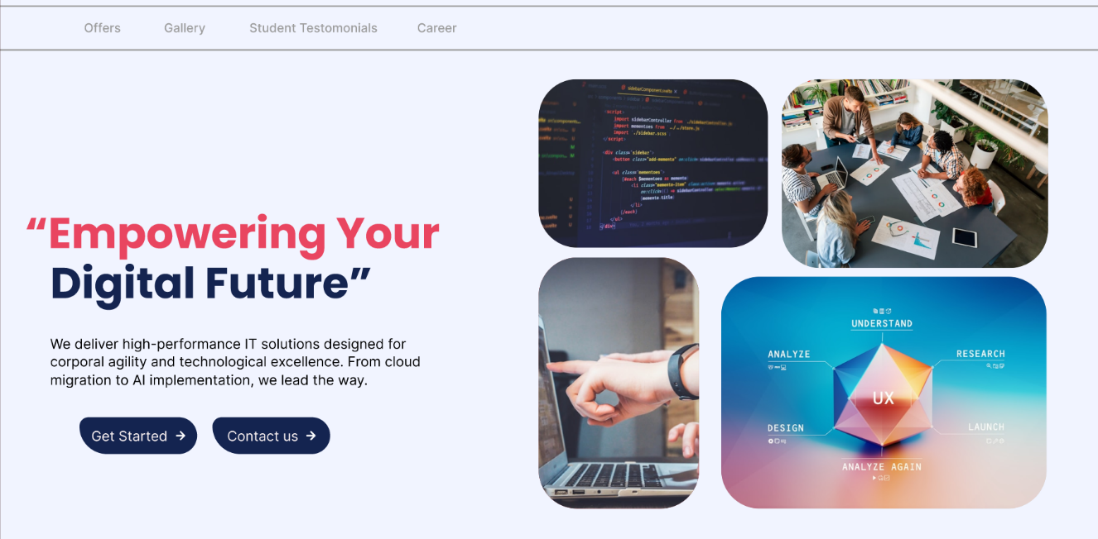

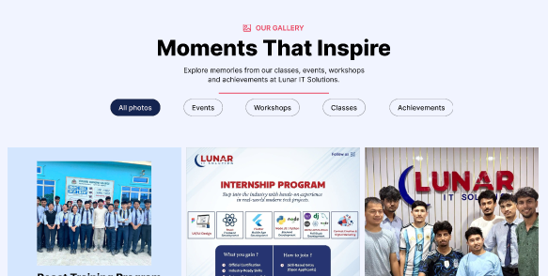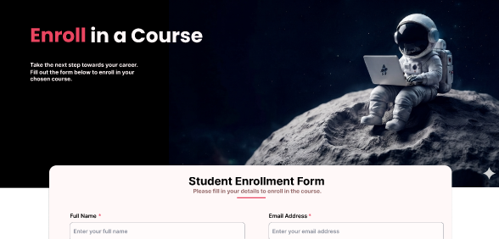

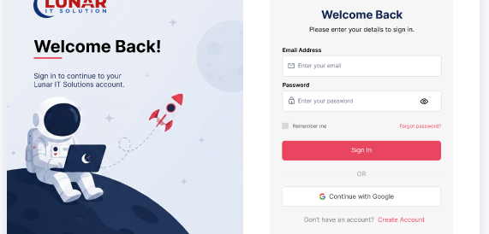

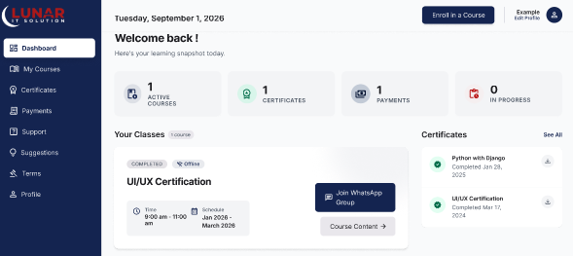

Appendix 2: Certificate

